# Lab: Data Types and Variables

Problems for exercises and homework for the "Programming Fundamentals" course @ SoftUni.

You can check your solutions in [Judge.](https://judge.softuni.org/Contests/3765)

# Integer and Real Numbers

## Convert Meters to Kilometers

You will be given an integer that will be a distance in meters. Write a program that converts meters to kilometers formatted to the second decimal point.

### Examples

|  |  |
| --- | --- |
| **Input** | **Output** |
| 1852 | 1.85 |
| 798 | 0.80 |

## Pounds to Dollars

Write a program that converts British pounds to US dollars formatted to the 3rd decimal point.

1 British Pound = 1.36 Dollars

### Examples

|  |  |
| --- | --- |
| **Input** | **Output** |
| 80 | 108.800 |
| 39 | 53.040 |

## Exact Sum of Real Numbers

Write a program to enter **n** numbers and calculate and print their **exact sum** (without rounding).

### Examples

|  |  |
| --- | --- |
| **Input** | **Output** |
| 3  1000000000000000000  5  10 | 1000000000000000015 |
| 2  0.00000000003  333333333333.3 | 333333333333.30000000003 |

### Hints

Use BigDecimal not to lose precision.

# Data Types and Type Conversion

## City Info

You will be given 3 lines of input. On the first line, you will be given the name of the city, on the second – the population, and on the third – the area. Use the correct data types and print the result in the following format:

"**City of {city name} has population of {population} and area {area} square km.**".

### Examples

|  |  |
| --- | --- |
| **Input** | **Output** |
| London  9002488  1572 | City of London has population of 9002488 and area 1572 square km. |
| Rome  4355725  1285 | City of Rome has population of 4355725 and area 1285 square km. |

## Concat Names

Read two names and a delimiter. Print the names joined by the delimiter.

### Examples

|  |  |
| --- | --- |
| **Input** | **Output** |
| John  Smith  -> | John->Smith |
| Jan  White  <-> | Jan<->White |
| Linda  Terry  => | Linda=>Terry |

## Chars to String

Write a program that reads 3 lines of input. On each line, you get a single character. Combine all the characters into one string and print it on the console.

### Examples

|  |  |
| --- | --- |
| **Input** | **Output** |
| a  b  c | abc |
| %  2  o | %2o |
| 1  5  p | 15p |

## Reversed Chars

Write a program that takes 3 lines of characters and prints them in reversed order with a space between them.

### Examples

|  |  |
| --- | --- |
| **Input** | **Output** |
| A  B  C | C B A |
| 1  L  & | & L 1 |

## Lower or Upper

Write a program that prints whether a given character is upper-case or lower-case.

### Examples

|  |  |
| --- | --- |
| **Input** | **Output** |
| L | upper-case |
| f | lower-case |

## Centuries to Minutes

Write a program to enter an integer number of **centuries** and convert it to **years**, **days**, **hours,** and **minutes**.

### Examples

|  |  |
| --- | --- |
| **Input** | **Output** |
| 1 | 1 centuries = 100 years = 36524 days = 876581 hours = 52594877 minutes |
| 5 | 5 centuries = 500 years = 182621 days = 4382906 hours = 262974384 minutes |

### Hints

* Use appropriate data types to fit the result after each data conversion.
* Assume that a year has 365.2422 days on average ([the Tropical year](https://en.wikipedia.org/wiki/Tropical_year)).

### Solution

You might help yourself with the code below:

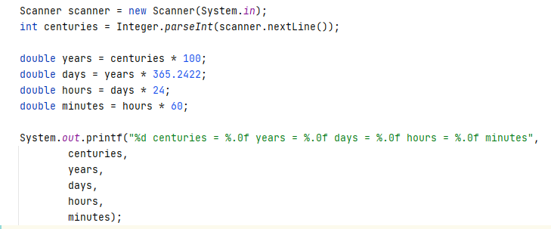

## Special Numbers

A **number** is **special** when its **sum of digits is 5, 7, or 11**.

Write a program to read an integer n and for all numbers in the range **1…n** to print the number and if it is special or not (True / False).

### Examples

|  |  |
| --- | --- |
| **Input** | **Output** |
| 15 | 1 -> False  2 -> False  3 -> False  4 -> False  5 -> True  6 -> False  7 -> True  8 -> False  9 -> False  10 -> False  11 -> False  12 -> False  13 -> False  14 -> True  15 -> False |
| 9 | 1 -> False  2 -> False  3 -> False  4 -> False  5 -> True  6 -> False  7 -> True  8 -> False  9 -> False |

### Hints

To calculate the sum of digits of given number num, you might repeat the following: sum the last digit (num % 10) and remove it (sum = sum / 10) until the num reaches 0.

# Variables

## Refactor Volume of Pyramid

You are given a **working code** that finds the **volume of a pyramid**. However, you should consider that the variables exceed their optimum span and have improper naming. Also, search for variables that have **multiple purposes**.

### Code

|  |
| --- |
| **Sample Code** |
| Scanner scanner = **new** Scanner(System.***in***);  **double** dul, sh, V = 0; System.***out***.print(**"Length: "**); dul = Double.*parseDouble*(scanner.nextLine()); System.***out***.print(**"Width: "**); sh = Double.*parseDouble*(scanner.nextLine()); System.***out***.print(**"Height: "**); V = Double.*parseDouble*(scanner.nextLine()); V = (dul * sh * V) / 3; System.***out***.printf(**"Pyramid Volume: %.2f"**, V); |

### Hints

* **Reduce the span** of the variables by declaring them at the moment they receive a value, not before
* Rename your variables to **represent their** real **purpose** (example: "dul" should become length, etc.)
* Search for variables that have multiple purposes. If you find any, **introduce a new variable**.

## Refactor Special Numbers

You are given a **working code** that is a solution to **Problem 10. Special Numbers**. However, the variables are **improperly named, declared before** they are needed, and some of them are used for multiple things. Without using your previous solution, **modify the code** so that it is **easy to read and understand**.

### Code

|  |
| --- |
| **Sample Code** |
| Scanner scanner = **new** Scanner(System.***in***);  **int** how = Integer.*parseInt*(scanner.nextLine()); **int** tol = 0; **int** hr = 0; **boolean** toe = **false**; **for** (**int** ch = 1; ch <= how; ch++) {  hr = ch;  **while** (ch > 0) {  tol += ch % 10;  ch = ch / 10;  }  toe = (tol == 5) || (tol == 7) || (tol == 11);  System.***out***.printf(**"%d -> %b%n"**, hr, toe);  tol = 0;  ch = hr; } |

### Hints

* Reduce the span of the variables by declaring them at the moment they receive a value, not before
* Rename your variables to represent their real purpose (example: "toe" should become isSpecialNum, etc.)
* Search for variables that have multiple purposes. If you find any, introduce a new variable